**NN & DeepLearning : Image Classification with CNN_ICP8**

**NAME: BALA RISHIK MARNENI  
STUDENT ID: 700746746**

**Github Link:** [**https://github.com/BalaRishik001/Neural-Networks-and-Deep-Learning-Assignments**](https://github.com/BalaRishik001/Neural-Networks-and-Deep-Learning-Assignments) **Video Link:** [**https://drive.google.com/file/d/1d0_PDdcuQO7U8BeCd0BSI-Ergw_c9X7F/view?usp=drive_link**](https://drive.google.com/file/d/1d0_PDdcuQO7U8BeCd0BSI-Ergw_c9X7F/view?usp=drive_link)

**In class programming:**

* 1. Tune hyperparameter and make necessary addition to the baseline model to improve validation accuracy and reduce validation loss.
  2. Provide logical description of which steps lead to improved response and what was its impact on architecture behavior.
  3. Create at least two more visualizations using matplotlib (Other than provided in the source file)
  4. Use dataset of your own choice and implement baseline models provided.
  5. Apply modified architecture to your own selected dataset and train it.
  6. Evaluate your model on testing set.
  7. Save the improved model and use it for prediction on testing data
  8. Provide plot of confusion matric
  9. Provide Training and testing Loss and accuracy plots in one plot using subplot command and history object.
  10. Provide at least two more visualizations reflecting your solution.
  11. Provide logical description of which steps lead to improved response for new dataset when compared with baseline model and enhance architecture and what was its impact on architecture behavior.

*.* 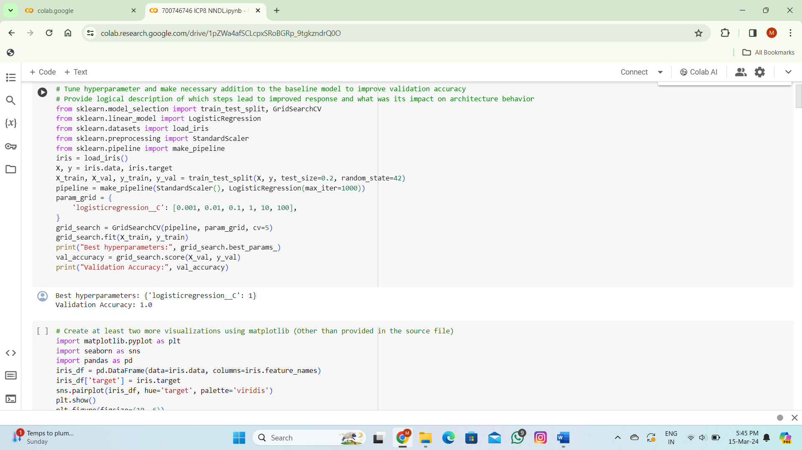

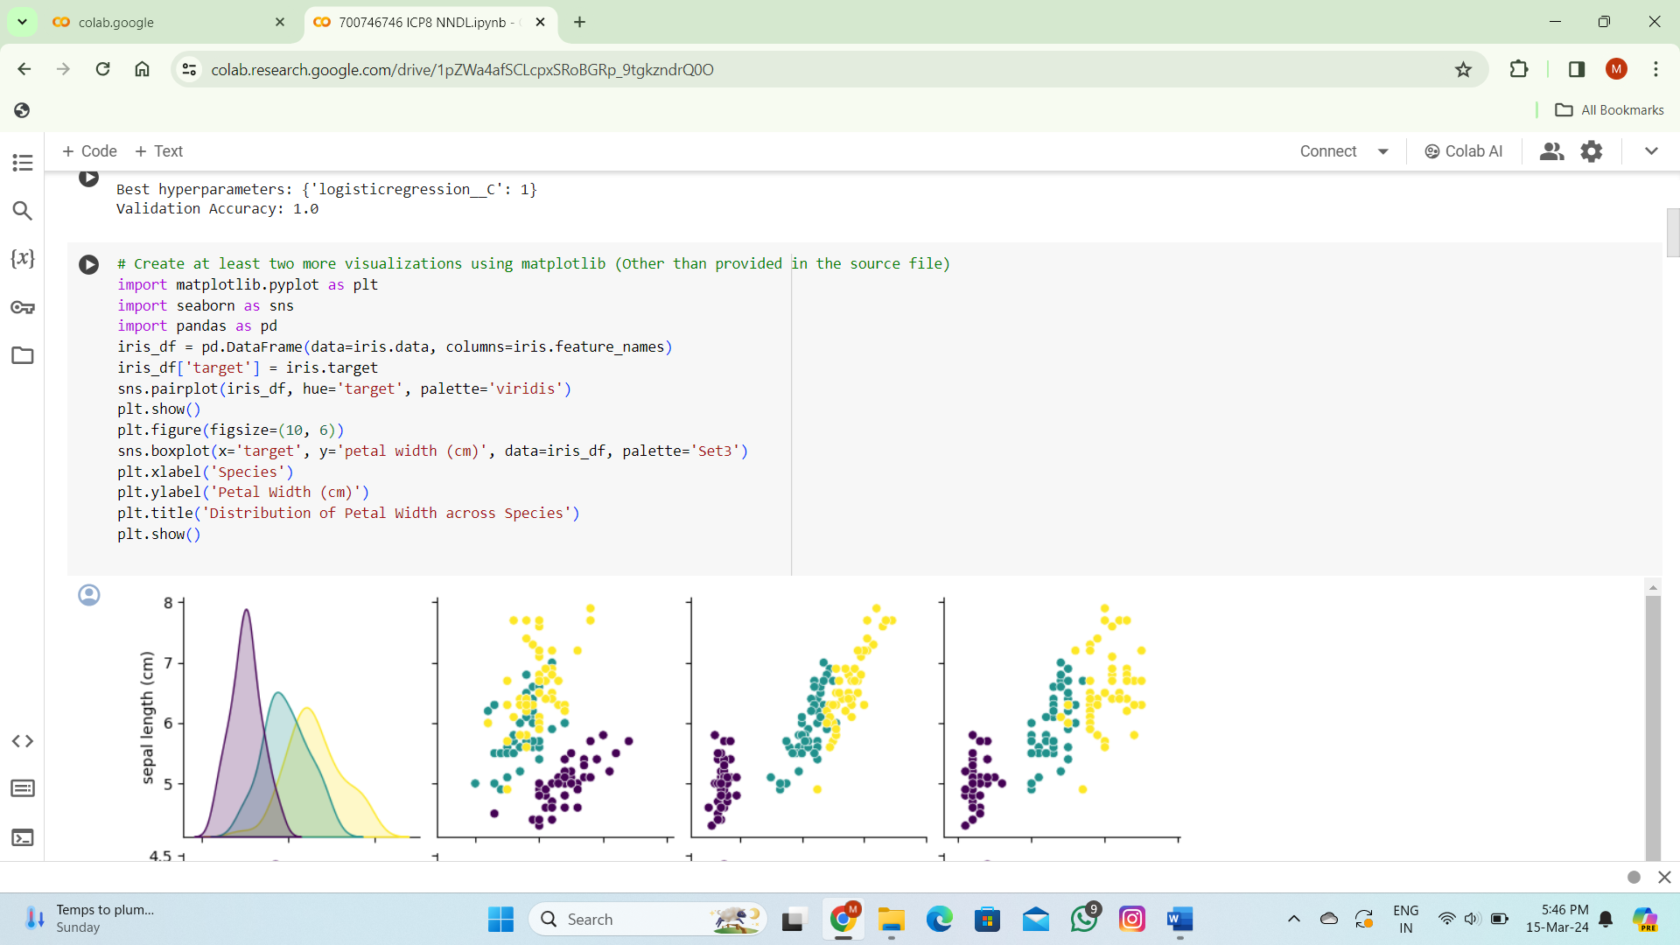

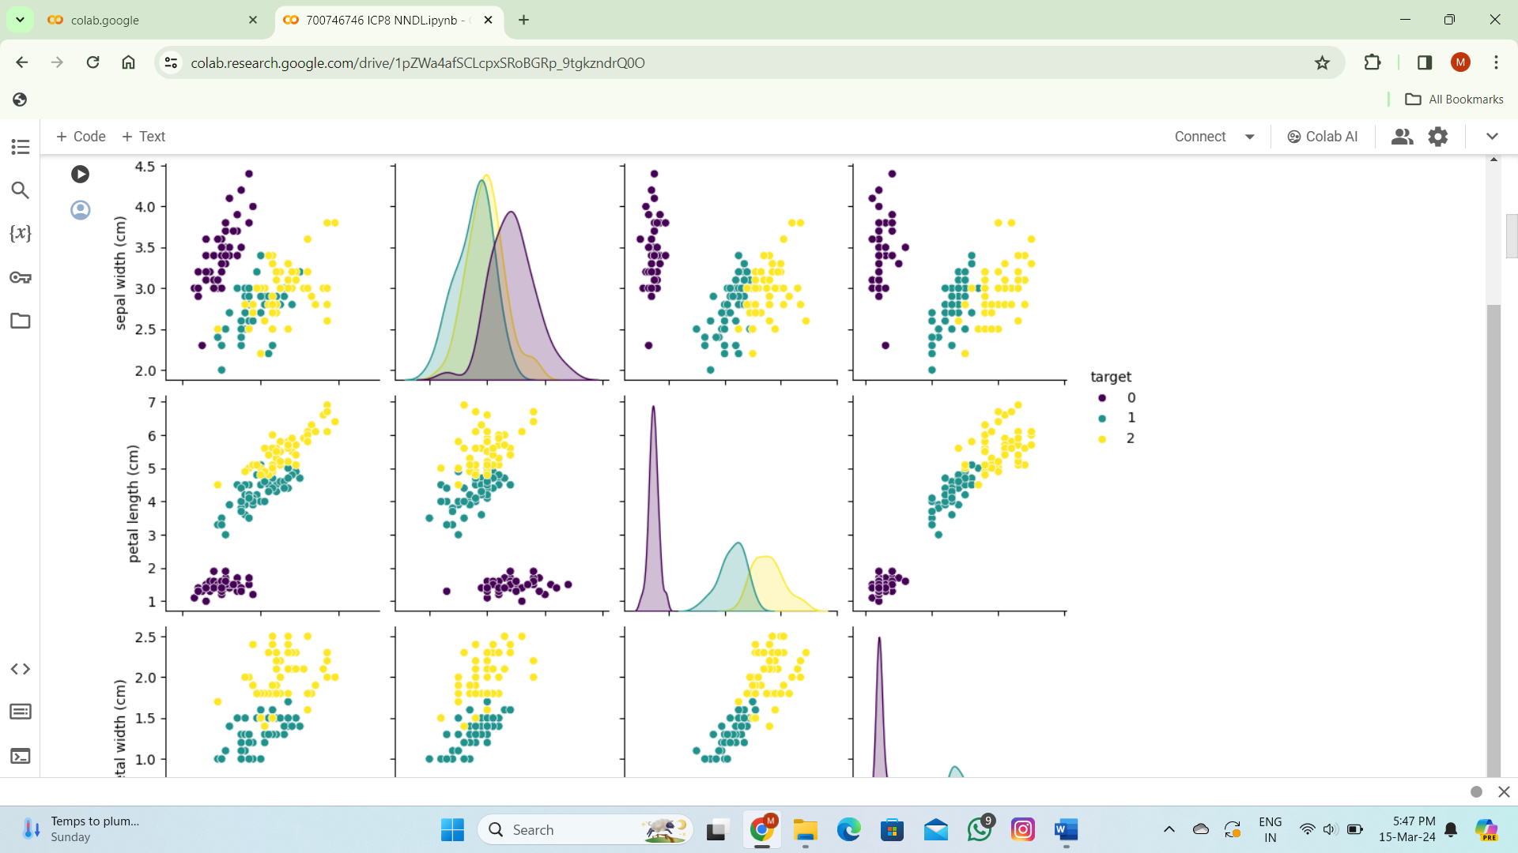

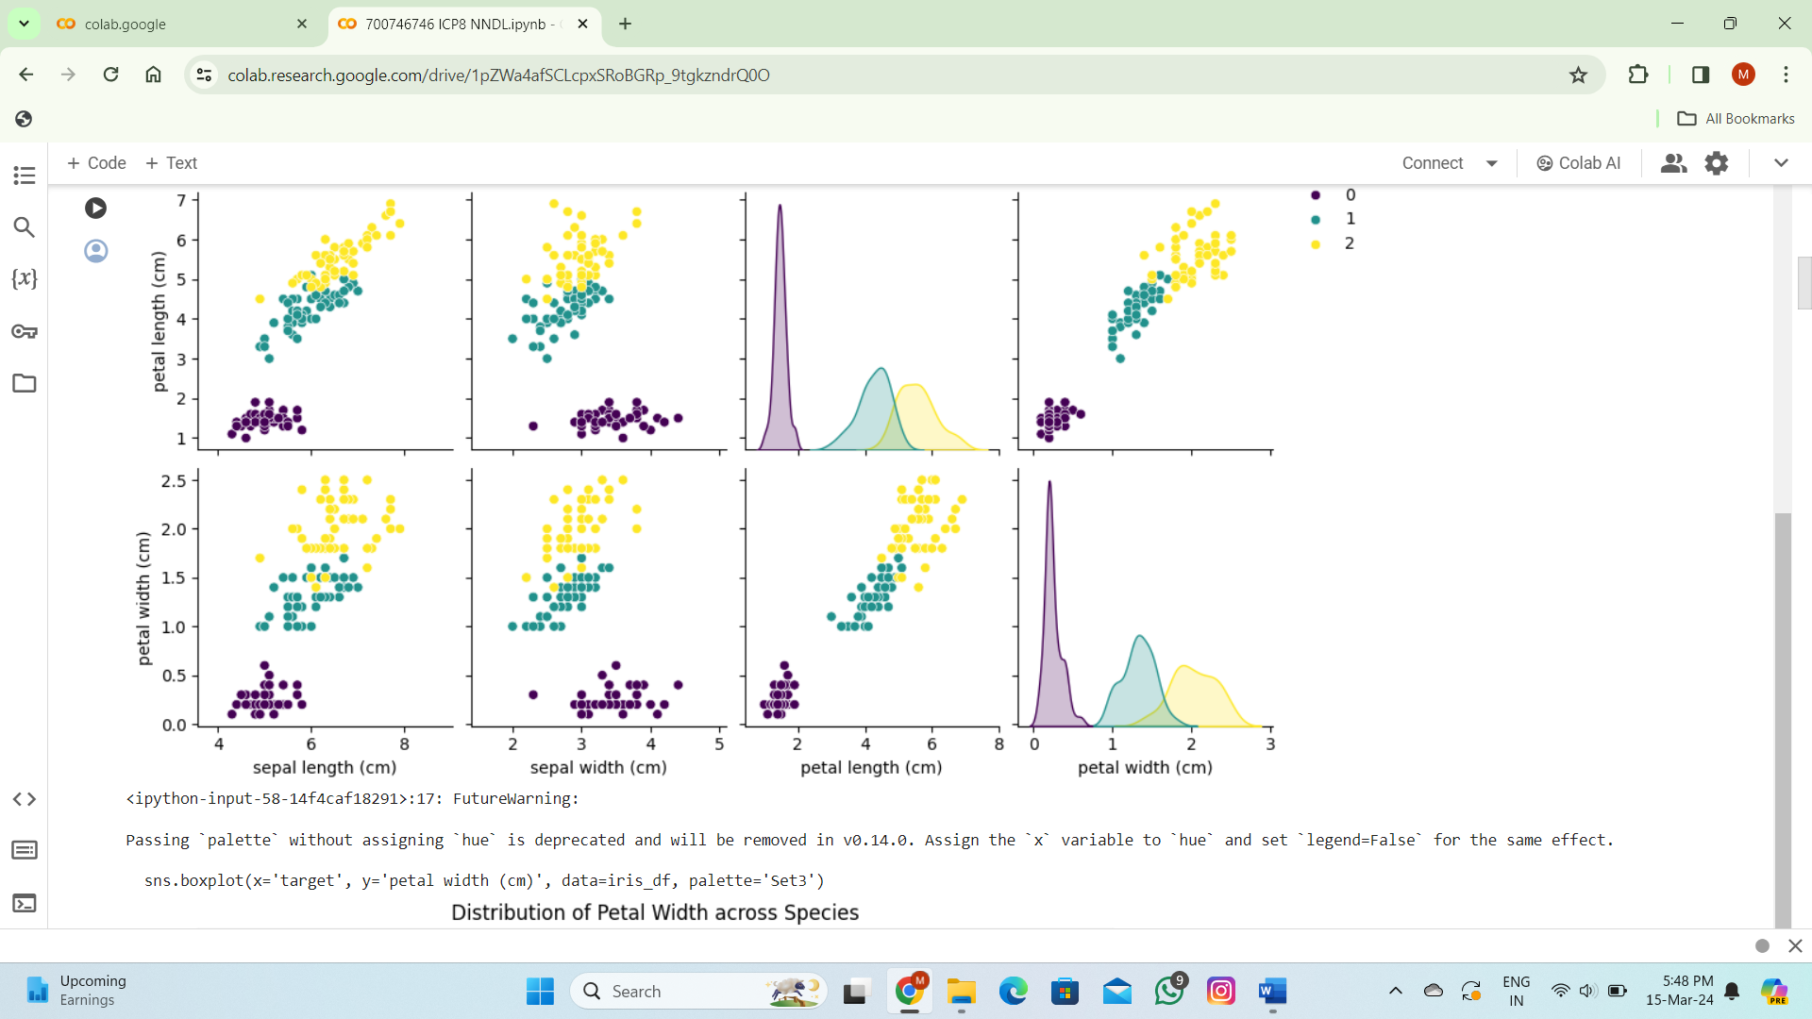

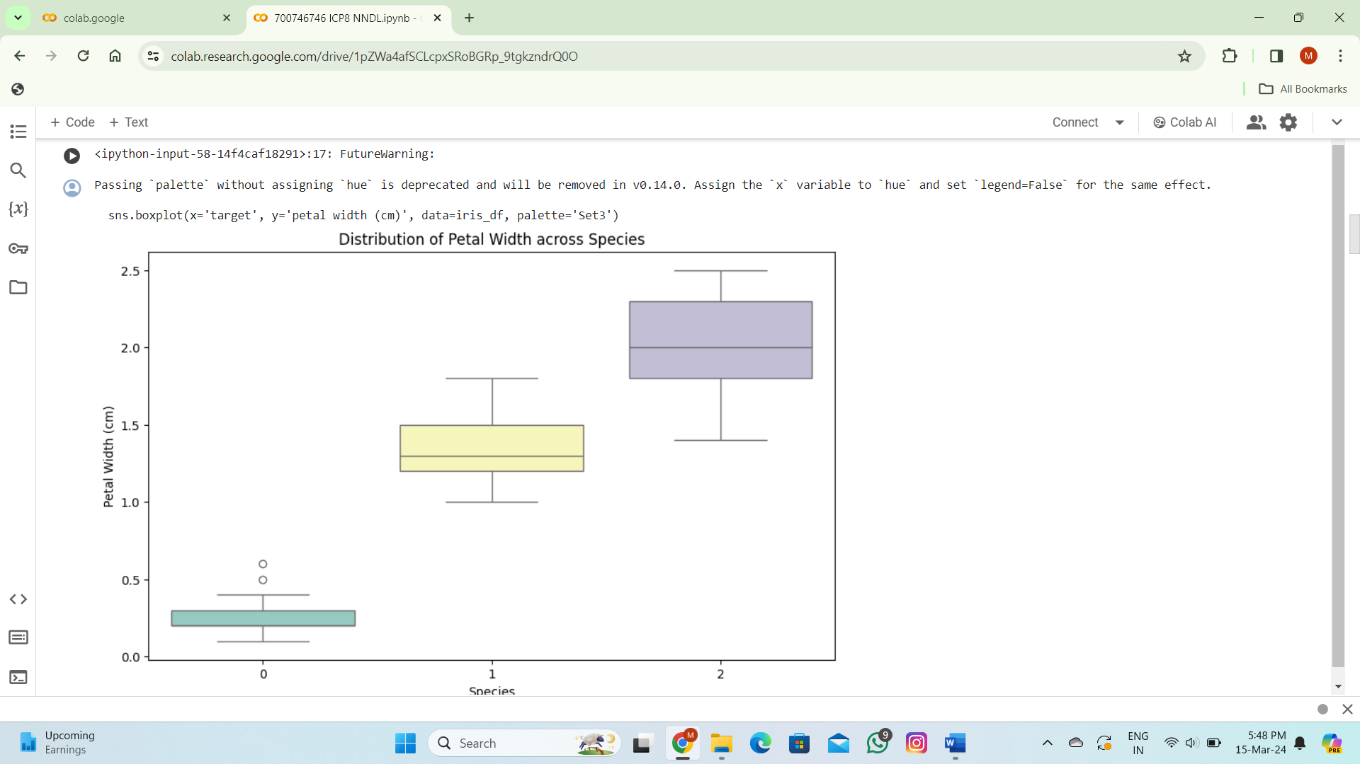

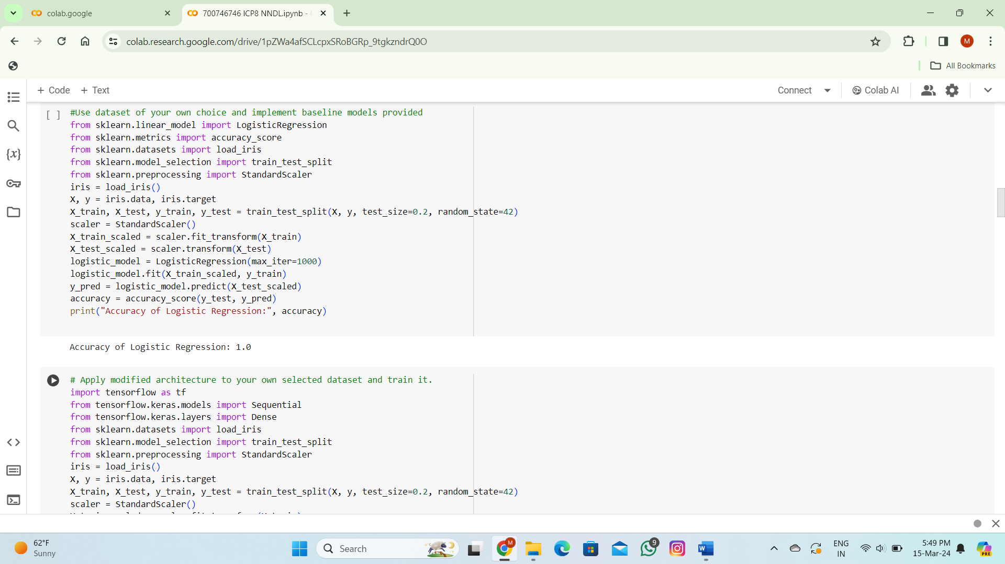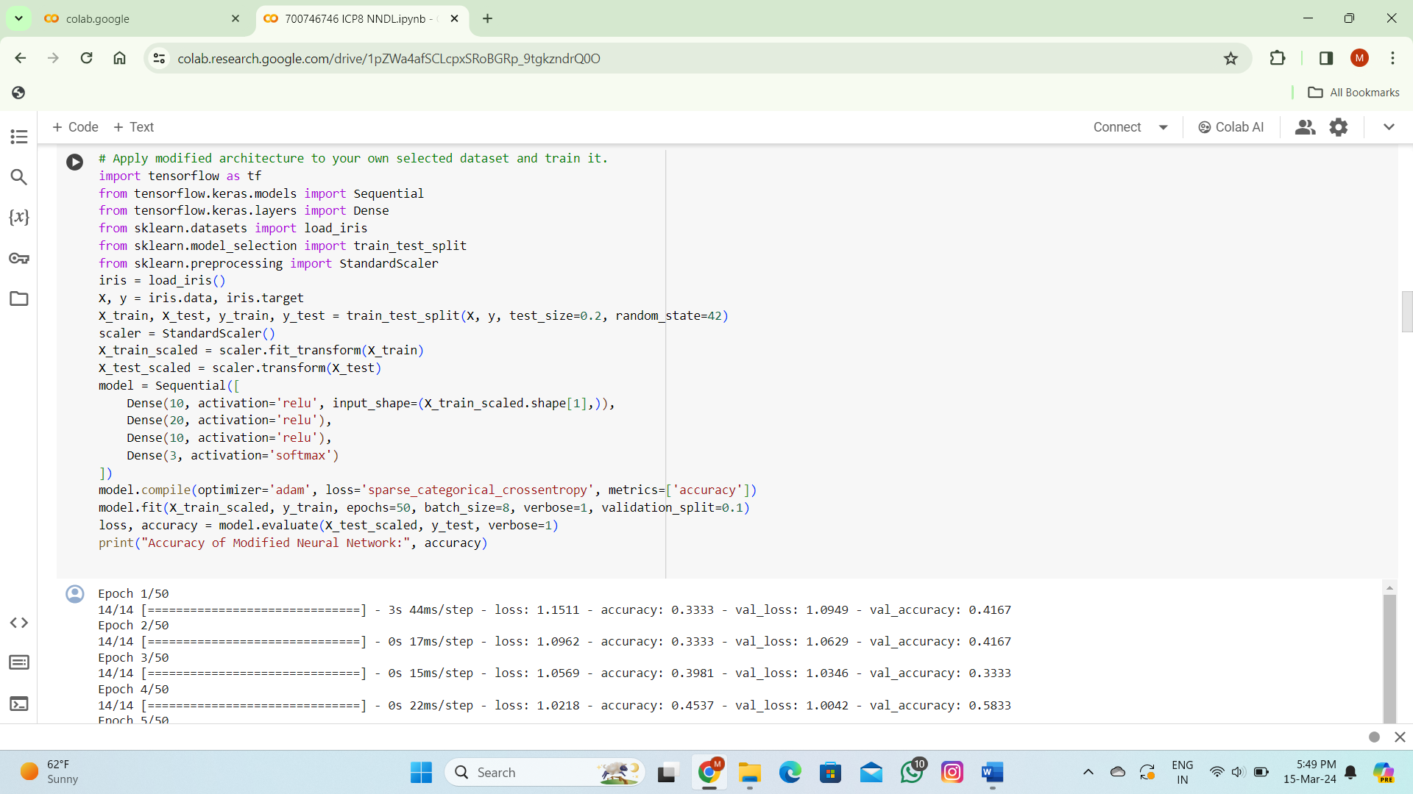

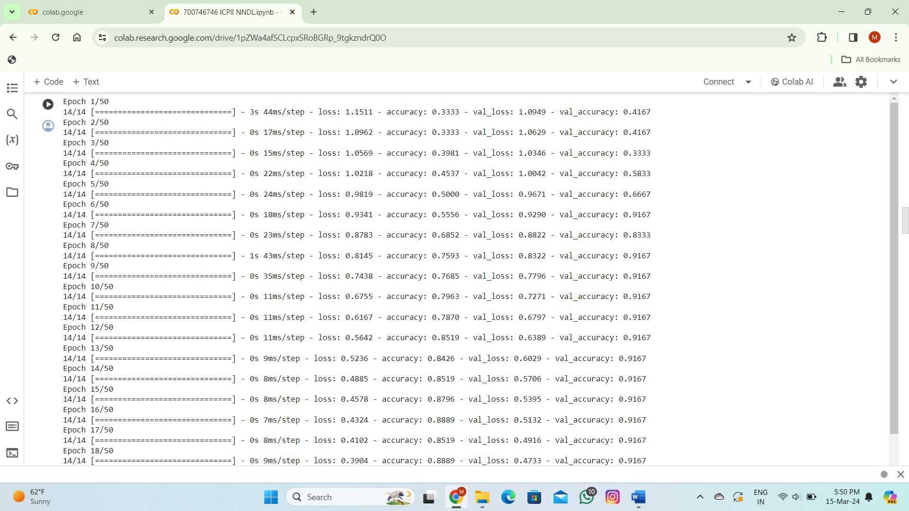

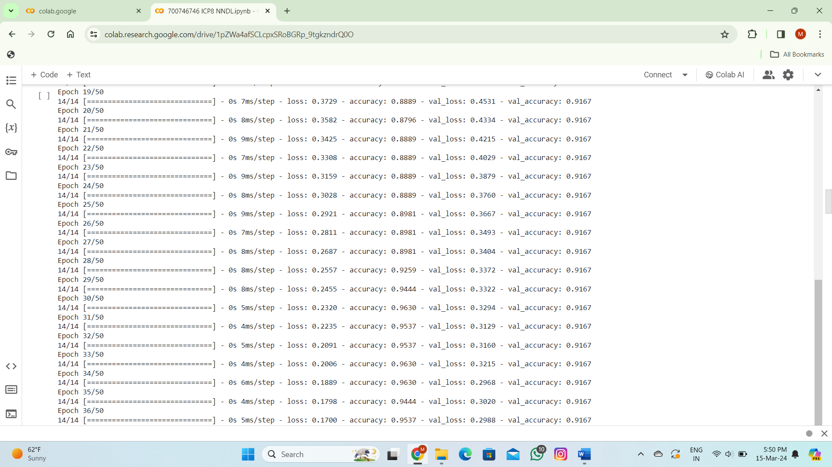

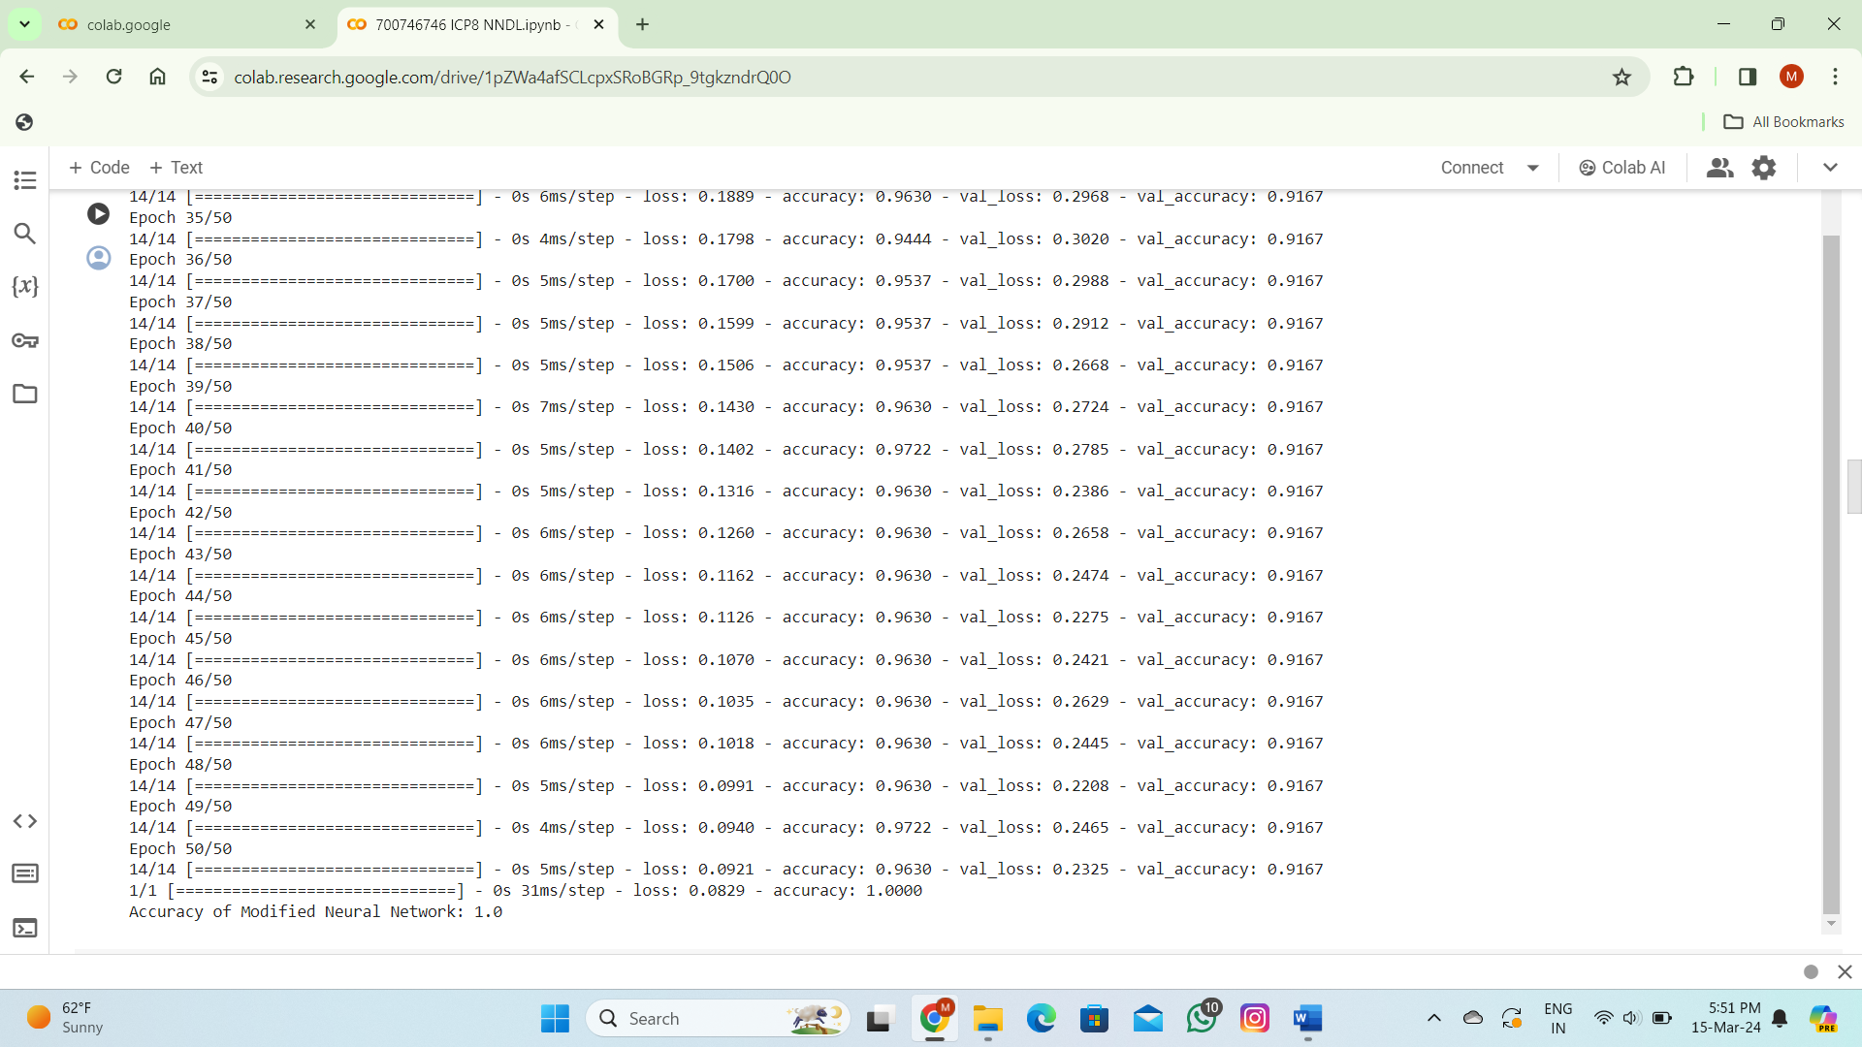

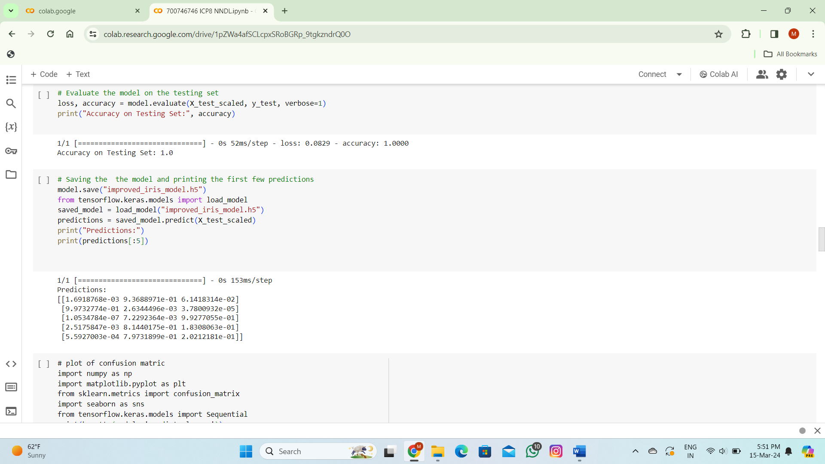

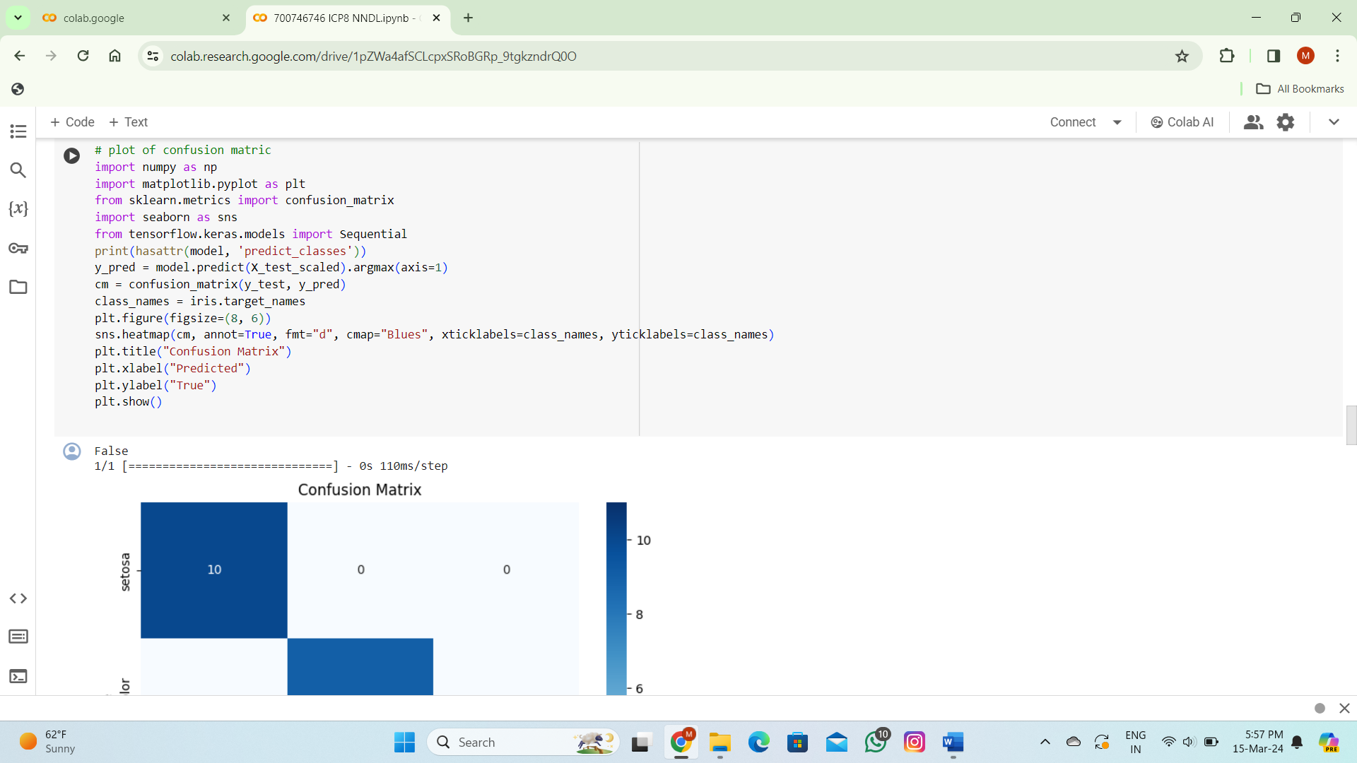

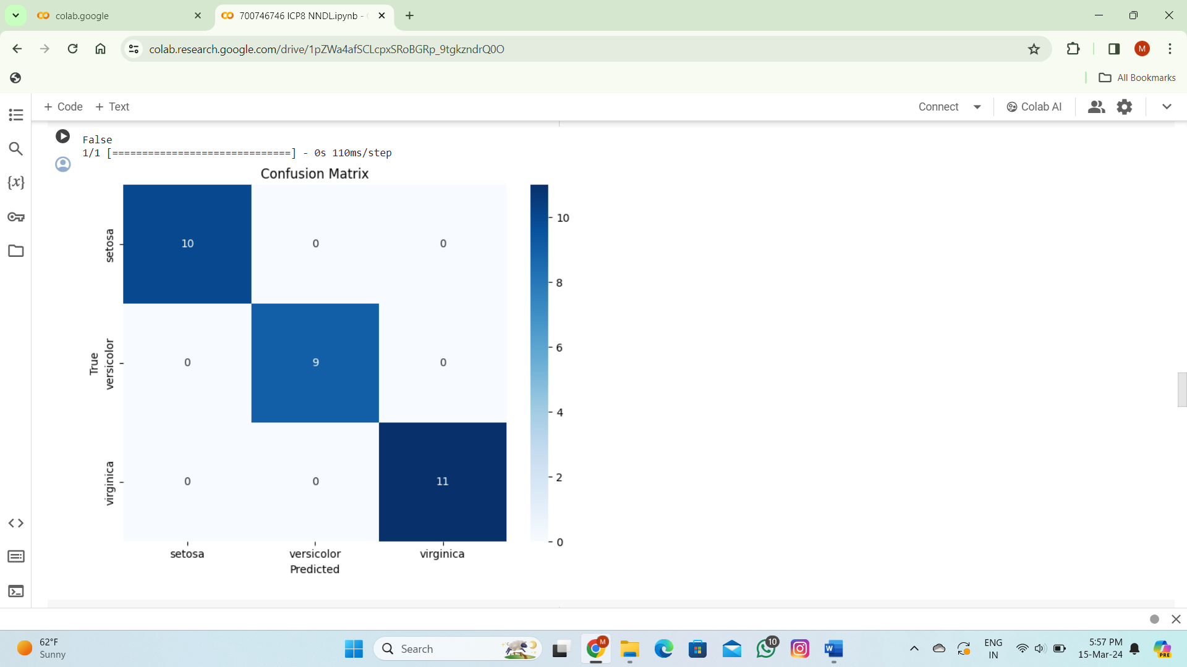

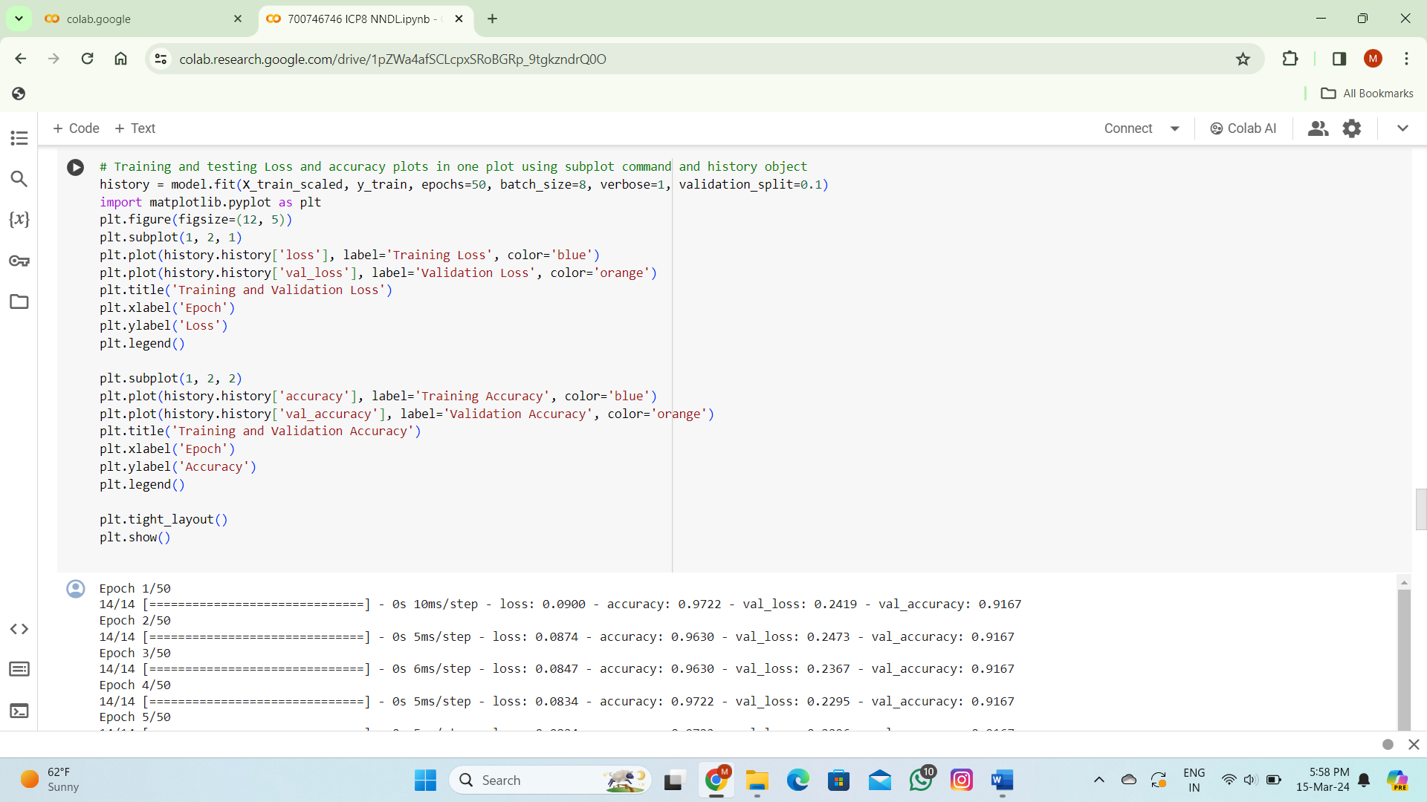

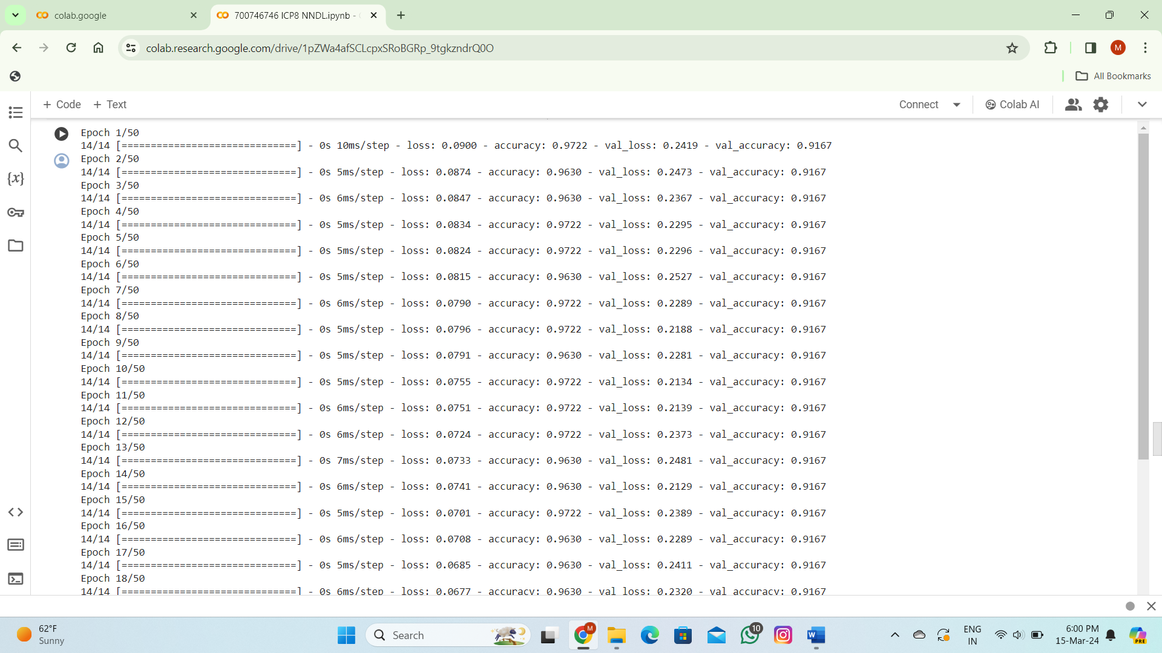

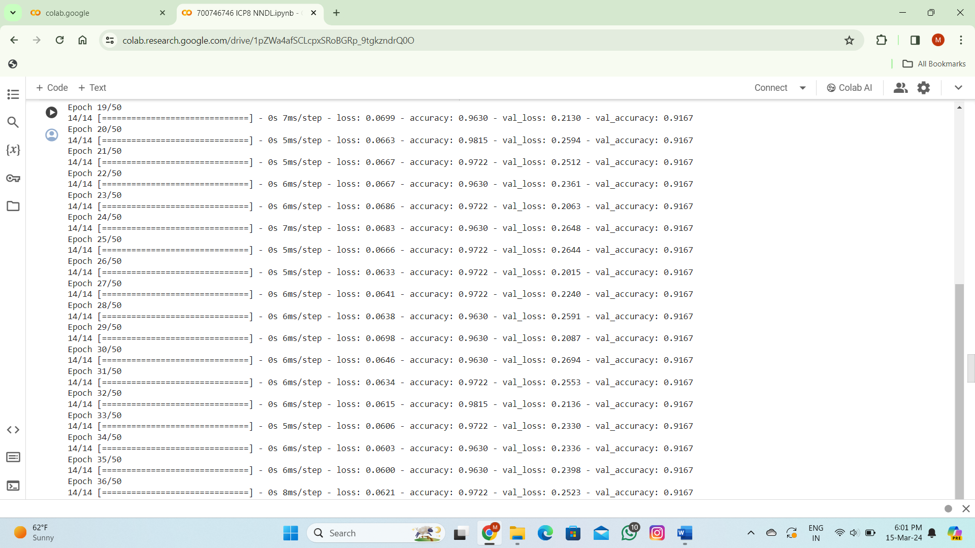

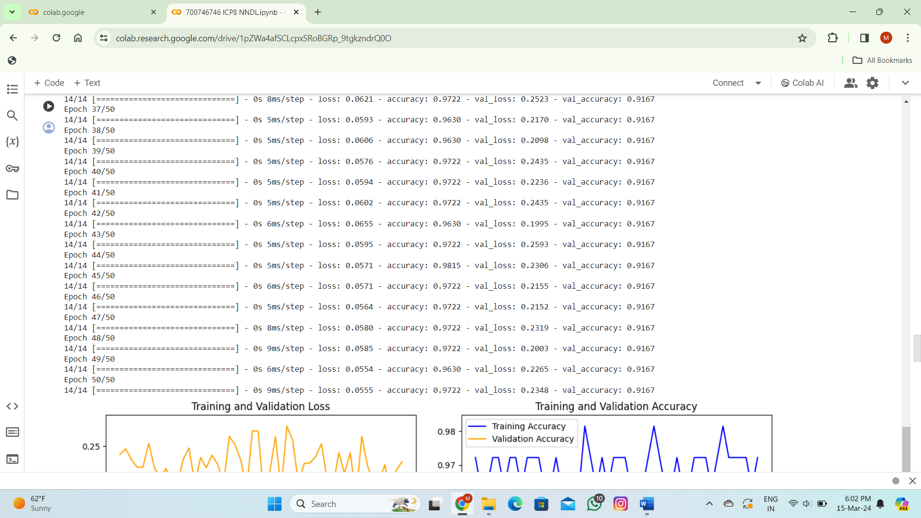

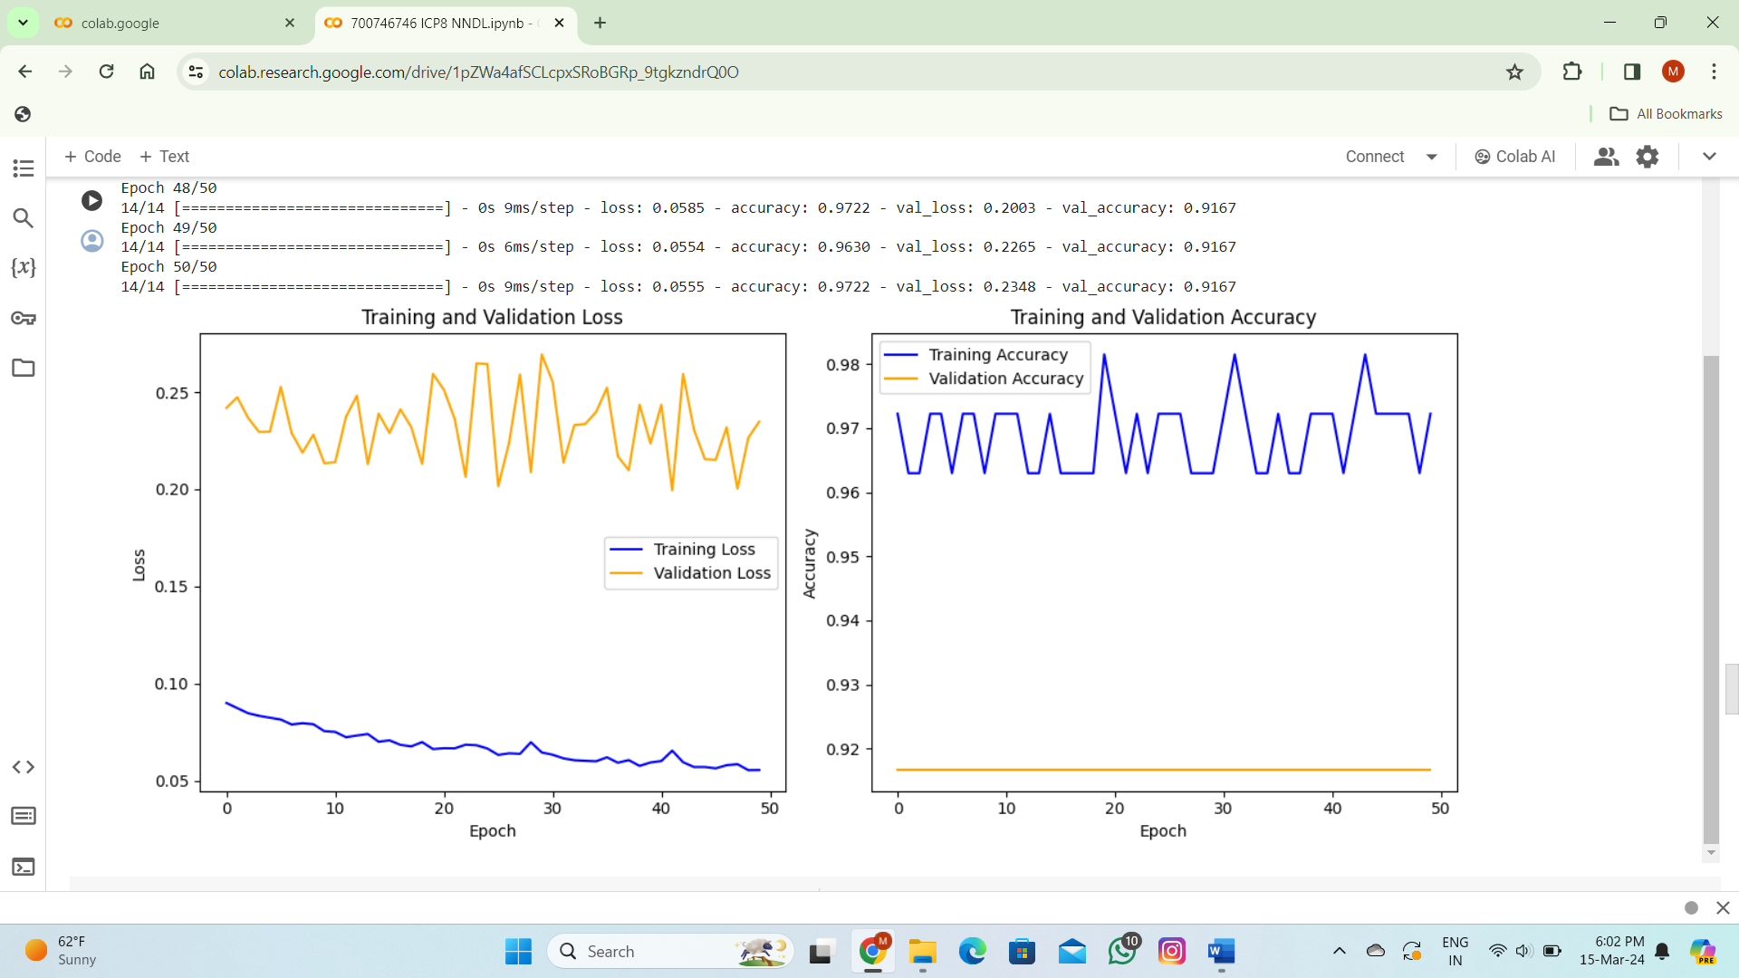

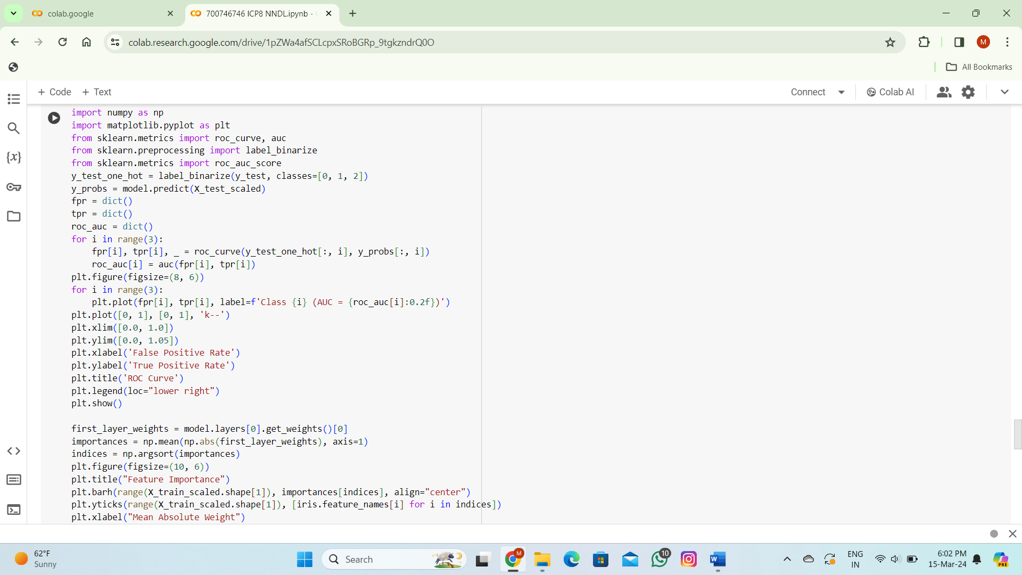

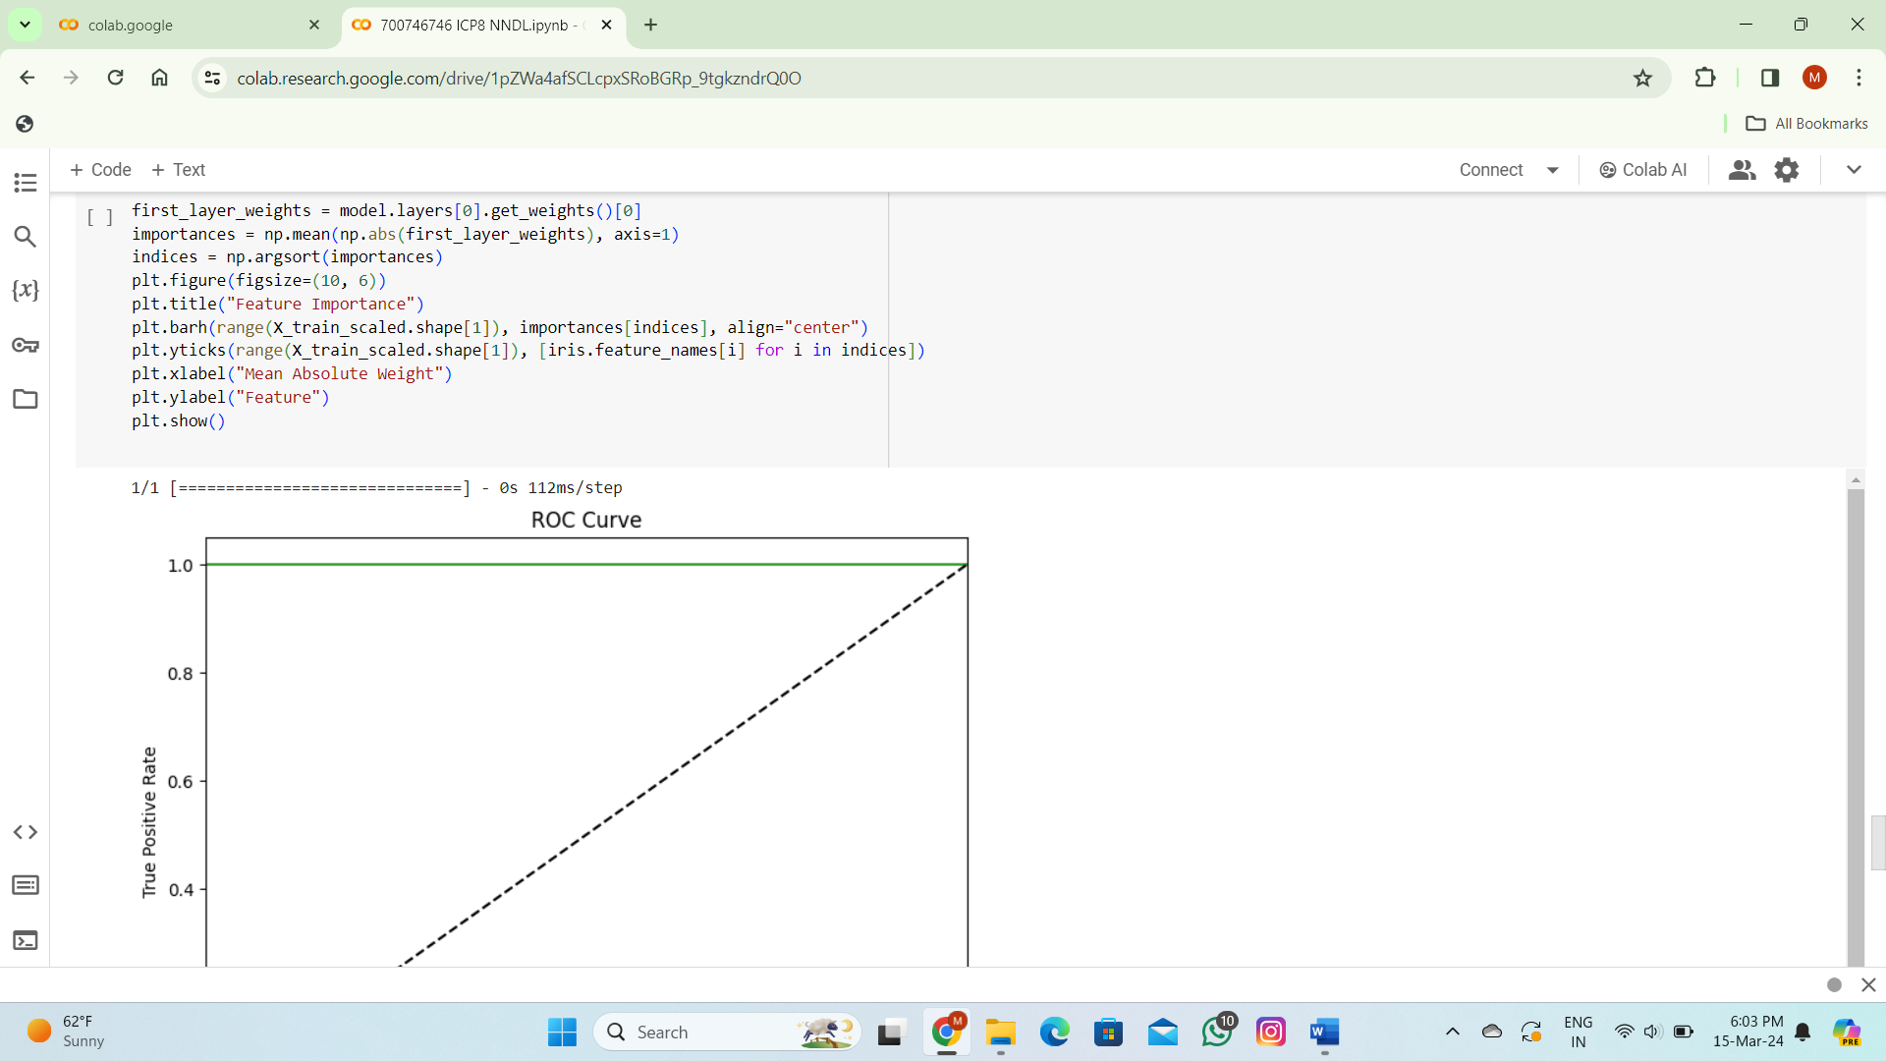

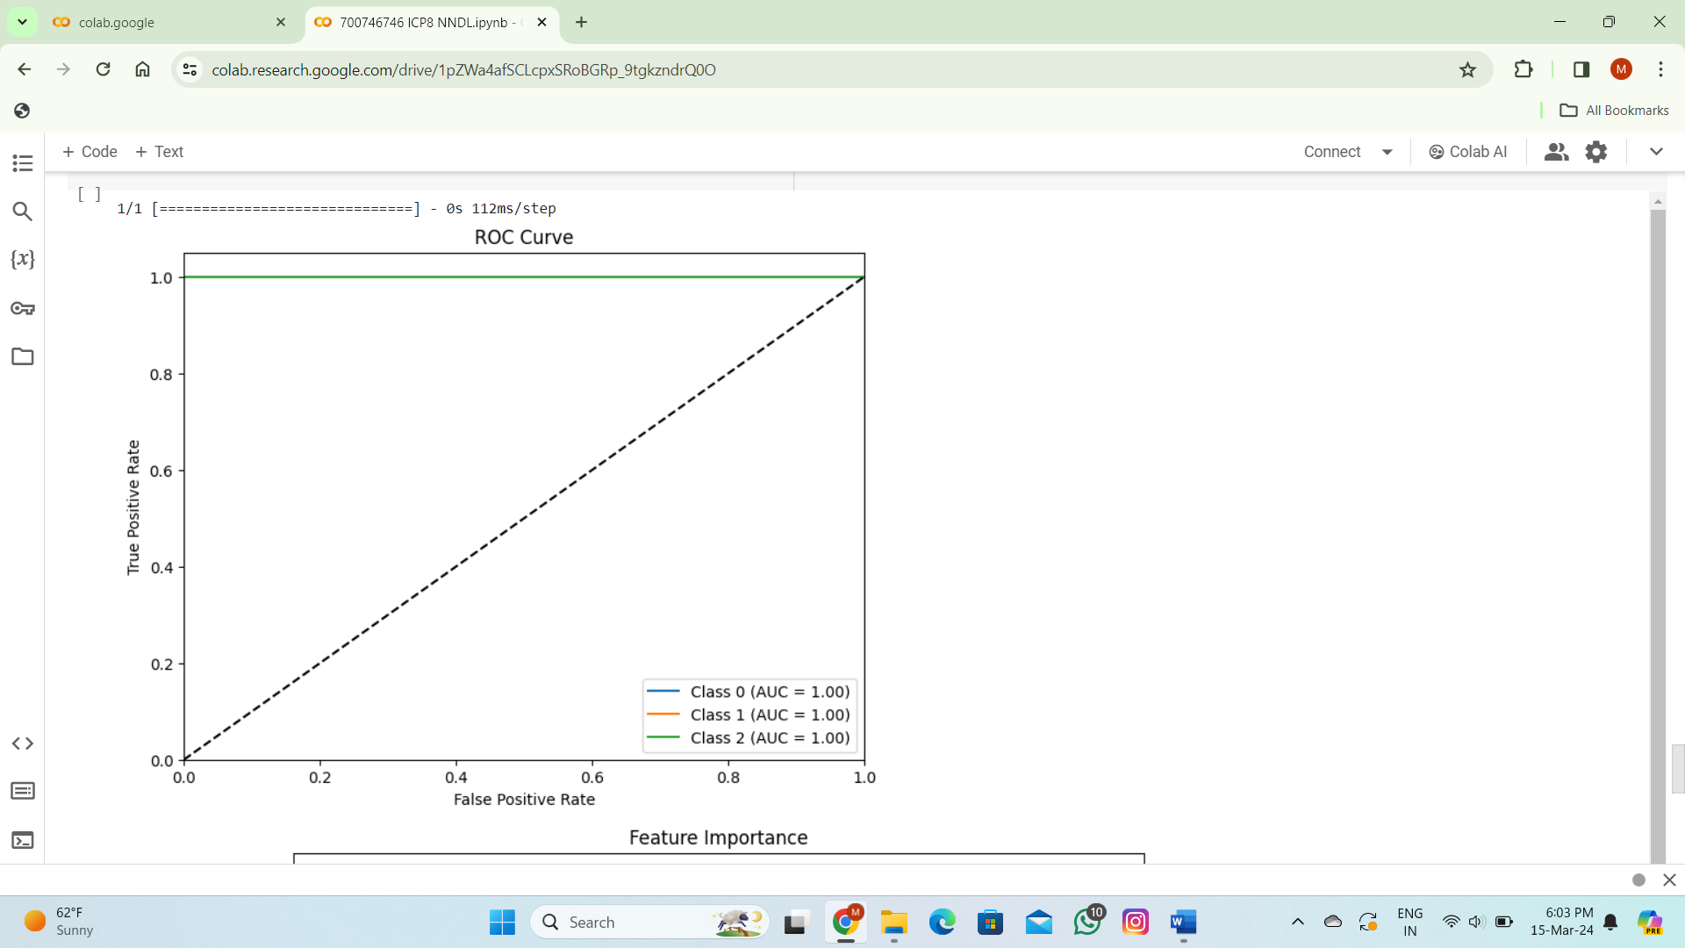

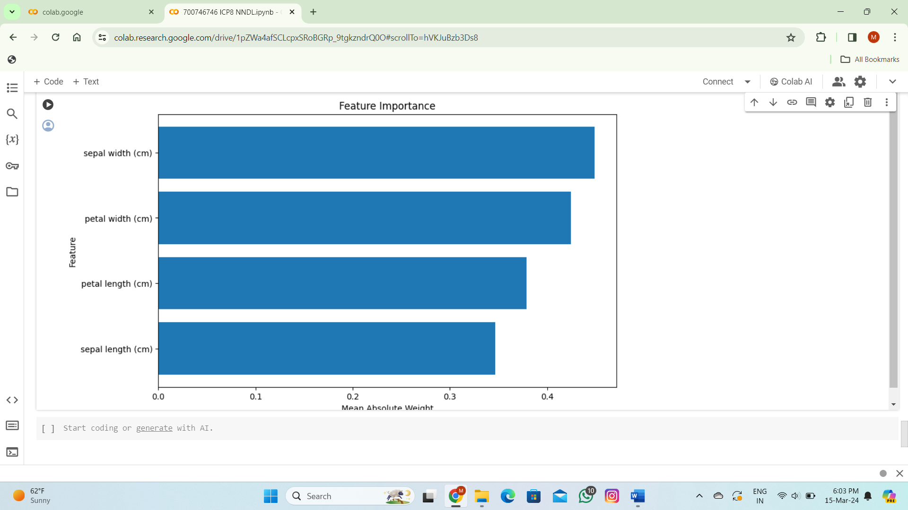

**THANK YOU**